**Hints for Project Two**

Sometimes it is useful to generate an event when the user tabs out of a TextBox. When the cursor leaves a TextBox, we say that the TextBox loses **Focus**. To have your TextBox generate an event when it loses focus, follow these instructions:

1. Select the TextBox that you want to generate the "loses focus" event.
2. In the Properties window, click on the Lightning Bolt at the top of the Window (see the illustration below). When you click the Lighting Bolt, you will see a long list of events that can be generated for the Text Box.
3. In the group labeled **Focus** you should see an event called "Leave".
4. Double click on this event name.
5. The skeleton code for an event handler for the "Leave" event will be generated.
6. Fill in the code that you want executed when this event is generated.

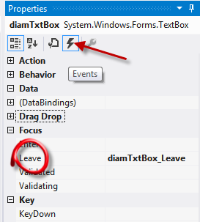

When you click on the Clear Button, you would like the cursor to end up in the TextBox ready for the user to enter in a new wheel diameter. You can do this by giving the TextBox focus. For example, suppose that your TextBox is named wheelTxtBox, then the code to give the TextBox focus would be

wheelTxtBox.Focus( );